Contents
1. Problem Understanding 2
a. Problem Statement 4
b. Need of the study/project 4
c. Understanding business/social opportunity 4
2. Data Report 5
a. Understanding how data was collected in terms of time, frequency and methodology 5
b. Visual inspection of data (rows, columns, descriptive details) 6
c. Understanding of attributes (variable info, renaming if required) 7
3. Exploratory Data Analysis 8
a. Variable Transformation 8
b. Data Type Conversion 12
c. Missing Value Treatment 12
d. Removal of unwanted variables 14
e. Duplicate records check 14
f. Univariate analysis (distribution and spread for every continuous attribute, distribution of data in categories for categorical ones) 14
g. Bivariate analysis (relationship between different variables, correlations) 20
h. Multivariate Analysis (Heatmap) 23
i. Outlier Treatment 24
4. Business insights from EDA 25
a. Is the data unbalanced? If so, what can be done? Please explain in the context of the business. 25
b. Any business insights using clustering 26
c. Any other business insights 28

Table Of Figures
Figure 1 - Shape of Dataset 6
Figure 2 - Dataset Info 7
Figure 3 - Tenure values 8
Figure 4 - Gender Values 8
Figure 5 - Account user count values 8
Figure 6 - Account segment values 8
Figure 7 - Rev_per_month values 9
Figure 8 - Rev_growth_yoy values 9
Figure 9 - Coupon used for payment values 9
Figure 10 - Days since CC connect 9
Figure 11 - Login device values 9
Figure 12 - Data types of variables 13
Figure 13 - Missing Values in Dataset 13
Figure 14 - Dataset Info 13
Figure 15 - Univariate Analysis of Tenure 14
Figure 16 - Univariate Analysis of CC contacted LY 15
Figure 17 - Univariate Analysis of Account user count 15
Figure 18 - Univariate Analysis of Revenue per month 15
Figure 19 - Univariate Analysis of Revenue growth yoy 16
Figure 20 - Univariate Analysis of Coupons used for payment 16
Figure 21 - Univariate Analysis of Days since CC connect 16
Figure 22 - Univariate Analysis of Cashback 17
Figure 23 - Frequency Distribution of Churn 17
Figure 24 - Frequency Distribution of City tier 17
Figure 25 - Frequency Distribution of Payment mode 18
Figure 26 - Frequency Distribution of Gender 18
Figure 27 - Frequency Distribution of Service Score 18
Figure 28 - Frequency Distribution of Account segment 19
Figure 29 - Frequency Distribution of CC agent score 19
Figure 30 - Frequency Distribution of Marital status 19
Figure 31 - Frequency Distribution of Login device 20
Figure 32 - Churn vs Tenure 20
Figure 33 - Churn vs Revenue 20
Figure 34 - City Tier vs Tenure 21
Figure 35 - Tenure vs Revenue 21
Figure 36 - Payment mode vs churn 21
Figure 37 - Gender vs churn 22
Figure 38 - Accounts users vs churn 22
Figure 39 - Account segment vs churn 22
Figure 40 - Service score vs churn 22
Figure 41 - Days since cc connect vs churn 23
Figure 42 - Heatmap of numerical variables 23
Figure 43 – Boxplots before outlier treatment 24
Figure 44 - Boxplots after outlier treatment 24
Figure 45 - Data Balance check 25
Figure 46 - Dendrogram (Hierarchical Clustering) 26
Figure 47 - Clusters shape 27
Figure 48 - Cluster Analysis 27

List of Tables
Table 1 - Data Dictionary 6
Table 2 - Continuous variable description 6
Table 3 - Categorical variable description 7
Table 4 - Cluster Aggregation 27

1. Problem Understanding

a. Problem Statement
An E Commerce company or DTH (you can choose either of these two domains) provider is facing a lot of competition in the current market and it has become a challenge to retain the existing customers in the current situation. Hence, the company wants to develop a model through which they can do churn prediction of the accounts and provide segmented offers to the potential churners. In this company, account churn is a major thing because 1 account can have multiple customers. hence by losing one account the company might be losing more than one customer.
You have been assigned to develop a churn prediction model for this company and provide business recommendations on the campaign.
Your campaign suggestion should be unique and be very clear on the campaign offer because your recommendation will go through the revenue assurance team. If they find that you are giving a lot of free (or subsidized) stuff thereby making a loss to the company; they are not going to approve your recommendation. Hence be very careful while providing campaign recommendation.

b. Need of the study/project
The amount of paying customers that fail to become repeat customers is known as customer churn, also known as customer attrition. Churn in this sense refers to a measurable rate of change that happens over a predetermined period of time.
Companies work to track, comprehend, and reduce customer churn since getting new customers is much more expensive than keeping existing ones.
If sales representatives and marketers can understand why customers churn, they can provide other stakeholders within the company with insight into how the organization's products and services can be improved.
Churn prediction means detecting which customers are likely to leave a service or to cancel a subscription to a service. Once we get to know of the customers who are likely to churn based on their characteristics, the organisation can work on betterment of things for these customers so that attrition of customers can be minimized.
Exploring the past data and generating insights from that helps in understanding why the churn rate is getting higher. Once we get to the bottom of the problem, the churn rate can be lessened. This project aims to find out the reasons for customer churning and trying to predict which customers in future might churn. All this study combined will help in bringing down the attrition rate.

c. Understanding business/social opportunity
Customer churn will cause the value flowing from customers to enterprises to decrease. If customer churn continues to occur, the enterprise will gradually lose its competitive advantage. When the growth of new customers cannot meet the needs of enterprise development, the enterprise will fall into a survival dilemma.
This project analyses the trends and causes of customer churn through data mining algorithms and gives the answers to such questions as how the customer churn occurs, the influencing factors of customer churn, and how enterprises win back churned customers.
The results of this paper can better serve the practice of customer relationship management in the telecom industry and provide a reference for the E-commerce or DTH industry to identify high-risk churned customers in advance, enhance customer loyalty and viscosity, maintain “high-value” customers, and continue to provide customers with “value” and reduce the cost of maintaining customers.

2. Data Report

a. Understanding how data was collected in terms of time, frequency and methodology
The data provided to us is of all the accounts associated with the organisation till date.
In total there are 11,260 accounts whose information has been provided to us. One account can have multiple customers as well.
Out of these accounts, some of the accounts have churned and rest are retained. The details (KPIs) related to all these accounts are captured and provided in a structured manner.
The data Dictionary is as given below:

Variable | Description
AccountID | account unique identifier
Churn | account churn flag (Target)
Tenure | Tenure of account
City_Tier | Tier of primary customer's city
CC_Contacted_L12m | How many times all the customers of the account has contacted customer care in last 12months
Payment | Preferred Payment mode of the customers in the account
Gender | Gender of the primary customer of the account
Service_Score | Satisfaction score given by customers of the account on service provided by company
Account_user_count | Number of customers tagged with this account
account_segment | Account segmentation on the basis of spend
CC_Agent_Score | Satisfaction score given by customers of the account on customer care service provided by company
Marital_Status | Marital status of the primary customer of the account
rev_per_month | Monthly average revenue generated by account in last 12 months
Complain_l12m | Any complaints has been raised by account in last 12 months
rev_growth_yoy | revenue growth percentage of the account (last 12 months vs last 24 to 13 month)
coupon_used_l12m | How many times customers have used coupons to do the payment in last 12 months
Day_Since_CC_connect | Number of days since no customers in the account has contacted the customer care
cashback_l12m | Monthly average cashback generated by account in last 12 months
Login_device | Preferred login device of the customers in the account
Table 1 - Data Dictionary

b. Visual inspection of data (rows, columns, descriptive details)
Starting with inspection of the dataset provided to us. We check for number fo rows and columns in it.
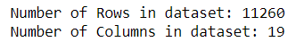
Figure 1 - Shape of Dataset
And then we check the description of the dataset that is provided to us.
We will be checking the distribution of these variables by dividing into categorical and continuous fields and summarize them one by one.
First, we check for continuous variables.
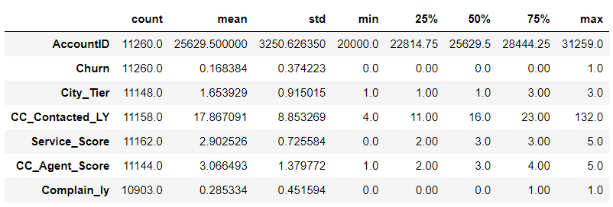
Table 2 - Continuous variable description
Account ID is the unique identifier of all data points. Churn is our target variable, 1 means the account churned while 0 means did not churn. City Tier is the tier of the city where the account belongs. It ranges from 1 to 3. Number of times customer care was contacted in last 12 months ranges from 4 ties to 132 times with an average of approximately 18.
Service score and customer care agent score ranges from 0 to 5 and 1 to 5 respectively.
** It is not mentioned in the problem that 0 is a better score or 5 is better, so we will be assuming in our project that 0 & 1 is a lower score and 5 is a higher score. **

Now we will look into the categorical variables:
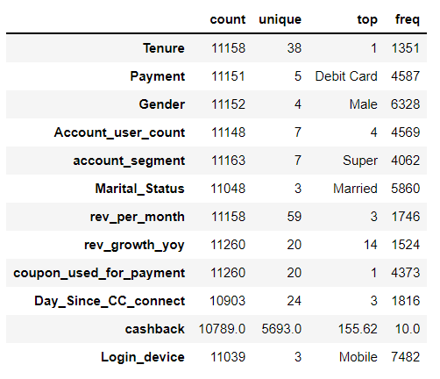
Table 3 - Categorical variable description
Payment is done in 5 different ways, most common is debit card. Most prominent gender of primary account holder is Male. There are 7 different account segments, most often customers go for ‘Super’ segment. Most of the primary account holder are married as well.
It can be seen that the variables are not correctly classified as categorical and numerical fields. We will have to make some changes in the raw data, clean the data, and then look into the description again.

c. Understanding of attributes (variable info, renaming if required)
Let us look into the information of all variables in the dataset:
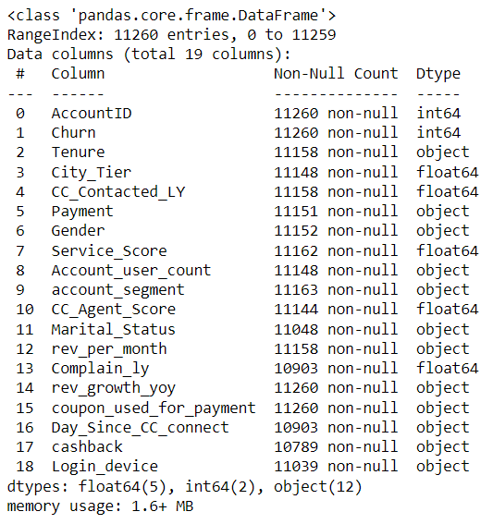
Figure 2 - Dataset Info
We can see that there are missing values in most of the variables and the variables are also not mapped to their correct data type. We will be cleaning the dataset in the EDA section.

3. Exploratory Data Analysis

a. Variable Transformation
We can see from the data information that we will have to do a lot of data cleaning and once the variables are cleaned, we will have to map them to their data type.
We will start with ‘Tenure’. If we check all unique values of Tenure, they are as follows:
Figure 3 - Tenure values
We see that there is a ‘#’ in Tenure as well which should be removed. So, we remove all the # from it and keep NaN values instead of that. Once done its data types changes to float as well.

Next to be checked is Gender. Gender values are as below:
Figure 4 - Gender Values
We can see that there are ‘F’ and ‘M’ mentioned for females and males. We won’t be taking two different values for one gender. Convert F to Female and M to Male. The final Gender variable will be having an object type datatype.

The we have Account user count. It has the following unique values:
Figure 5 - Account user count values
We have an ‘@’ in this variable which we have to clean. So we will remove it and put NaN instead of this. Final data type will be float.

Then we have account segment. Its unique values are:
Figure 6 - Account segment values
We will convert ‘Regular +’ into ‘Regular plus’ and ‘Super +’ to ‘Super plus’ which would be removing the discrepancy in values. Final data type will be object.
Then we have revenue per month. Unique values of this field are:
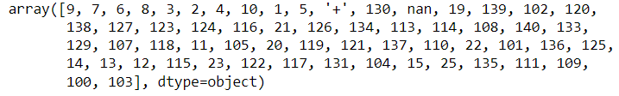
Figure 7 - Rev_per_month values
There is a ‘+’ sign in it. We remove this ‘+’ sign and put nan in place of that. Data type changes to float in this case.

Next is revenue growth yoy. Unique values are as follows:
Figure 8 - Rev_growth_yoy values
There is a ‘$’ sign being the reason of discrepancy. We remove it and NaN values are kept in place of it. Final data type is float.

Next is coupon used for payment. Unique values in dataset:
Figure 9 - Coupon used for payment values
Presence of ‘#’, ‘$’ and ‘*’ are proving to be problematic with this variable. We will be removing these and replace with NaN. Final data type will be float.

Then we check Days since last connect. It has following unique values:
Figure 10 - Days since CC connect
We can see that the ‘$’ is the problem in this field. We replace that with NaN. Final data type will be float.
Our next continuous variable is cashback. It has multiple numerical values but along with that has 2 ‘$’ signs in it as well. We will replace the 2 $ signs with NaN. Its dat type will be converted to float.
Finally, we have Login device. Its unique values are as follows:
Figure 11 - Login device values
The ‘&&&&’ values are replaced with NaN. Final data type remains object.
Now all the variables are cleaned. Let us finally check the unique values each variable has and its data type.

Feature: AccountID
Unique Values
[20000 20001 20002 ... 31257 31258 31259]
data type of AccountID is int64

Feature: Churn
Unique Values
[1 0]
data type of Churn is int64

Feature: Tenure
Unique Values
[ 4. 0. 2. 13. 11. nan 9. 99. 19. 20. 14. 8. 26. 18. 5. 30. 7. 1.
23. 3. 29. 6. 28. 24. 25. 16. 10. 15. 22. 27. 12. 21. 17. 50. 60. 31.
51. 61.]
data type of Tenure is float64

Feature: City_Tier
Unique Values
[ 3. 1. nan 2.]
data type of City_Tier is float64

Feature: CC_Contacted_LY
Unique Values
[ 6. 8. 30. 15. 12. 22. 11. 9. 31. 18. 13. 20. 29. 28.
26. 14. 10. 25. 27. 17. 23. 33. 19. 35. 24. 16. 32. 21.
nan 34. 5. 4. 126. 7. 36. 127. 42. 38. 37. 39. 40. 41.
132. 43. 129.]
data type of CC_Contacted_LY is float64

Feature: Payment
Unique Values
['Debit Card' 'UPI' 'Credit Card' 'Cash on Delivery' 'E wallet' nan]
data type of Payment is object

Feature: Gender
Unique Values
['Female' 'Male' nan]
data type of Gender is object

Feature: Service_Score
Unique Values
[ 3. 2. 1. nan 0. 4. 5.]
data type of Service_Score is float64

Feature: Account_user_count
Unique Values
[ 3. 4. nan 5. 2. 1. 6.]
data type of Account_user_count is float64

Feature: account_segment
Unique Values
['Super' 'Regular Plus' 'Regular' 'HNI' nan 'Super Plus']
data type of account_segment is object

Feature: CC_Agent_Score
Unique Values
[ 2. 3. 5. 4. nan 1.]
data type of CC_Agent_Score is float64

Feature: Marital_Status
Unique Values
['Single' 'Divorced' 'Married' nan]
data type of Marital_Status is object

Feature: rev_per_month
Unique Values
[ 9. 7. 6. 8. 3. 2. 4. 10. 1. 5. nan 130. 19. 139.
102. 120. 138. 127. 123. 124. 116. 21. 126. 134. 113. 114. 108. 140.
133. 129. 107. 118. 11. 105. 20. 119. 121. 137. 110. 22. 101. 136.
125. 14. 13. 12. 115. 23. 122. 117. 131. 104. 15. 25. 135. 111.
109. 100. 103.]
data type of rev_per_month is float64

Feature: Complain_ly
Unique Values
[ 1. 0. nan]
data type of Complain_ly is float64

Feature: rev_growth_yoy
Unique Values
[11. 15. 14. 23. 22. 16. 12. 13. 17. 18. 24. 19. 20. 21. 25. 26. nan 4.
27. 28.]
data type of rev_growth_yoy is float64

Feature: coupon_used_for_payment
Unique Values
[ 1. 0. 4. 2. 9. 6. 11. 7. 12. 10. 5. 3. 13. 15. 8. nan 14. 16.]
data type of coupon_used_for_payment is float64

Feature: Day_Since_CC_connect
Unique Values
[ 5. 0. 3. 7. 2. 1. 8. 6. 4. 15. nan 11. 10. 9. 13. 12. 17. 16.
14. 30. 46. 18. 31. 47.]
data type of Day_Since_CC_connect is float64

Feature: cashback
Unique Values
[159.93 120.9 nan ... 227.36 226.91 191.42]
data type of cashback is float64

Feature: Login_device
Unique Values
['Mobile' 'Computer' nan]
data type of Login_device is object

b. Data Type Conversion
We can see from our dataset that most the variables are not mapped to their correct data type. We will change each data type into the format it should be in.
- AccountID - Integer
- Churn - Object
- Tenure - Integer
- City_tier - Object
- CC_Contacted_LY - Integer
- Payment - Object
- Gender - Object
- Service_Score - Object
- Account_user_count - Integer
- Account_segment - Object
- CC_Agent_Score - Object
- Marital_Status - Object
- Rev_per_month - Integer
- Complain_ly - Object
- Rev_growth_yoy - Integer
- Coupon_used_for_payment - Integer
- Day_Since_CC_connect - Integer
- Cashback - Integer
- Login_device - Object

All variables are now mapped to their correct data type.

c. Missing Value Treatment
Let us now check the number of missing values in each variable and treat them.
We will be checking the missing values using isnull() function.
Missing values of each variable is mentioned below:
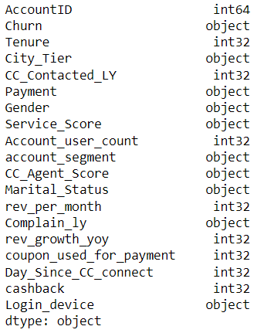
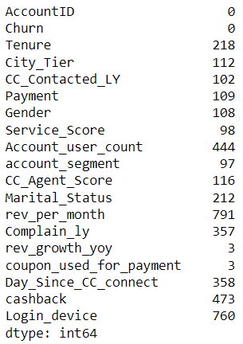

Figure 12 - Data types of variables
Figure 13 - Missing Values in Dataset

The missing values in each variable are treated based on whether the variable is a categorical one or a continuous one.
For continuous variables, the missing values are imputed with the mean value of the entire field and for categorical variables, we find the mode of all the values of the field and impute the missing values with that.
After the above steps, let us check the info of our dataset again.
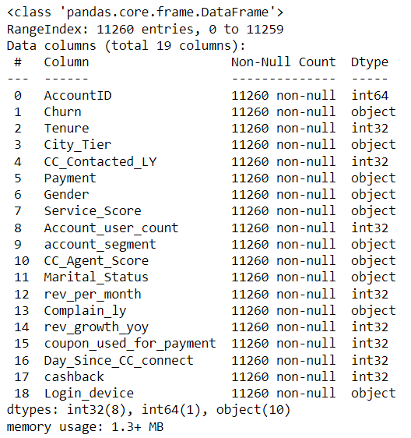
Figure 14 - Dataset Info
All missing values have been treated. All variables are mapped to their correct data type as well.

d. Removal of unwanted variables
For our model building exercise, ‘Account ID’, which is a unique identifier of all accounts has no part. It will be of no help in Machine Learning algorithm and is hence treated as an unwanted variable. We will be taking off this variable from our data frame.
The final shape of the dataset will now become:
Number of rows – 11260
Number of columns – 18

e. Duplicate records check
After removing the unwanted variable, we will now be checking for any duplicates in the dataset. Duplicates provide no extra meaning to the dataset; they just take extra processing time for our Machine Learning algorithm.
In our dataset, we find out that there are 308 duplicate records. We will be eliminating those as well from our dataset.
After removing duplicates, the shape of the dataset becomes:
Number of rows – 10952
Number of columns – 18

f. Univariate analysis (distribution and spread for every continuous attribute, distribution of data in categories for categorical ones)
We will start with univariate analysis of numerical variables. We will be covering description, distribution and boxplot of these variables.
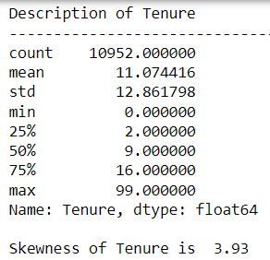
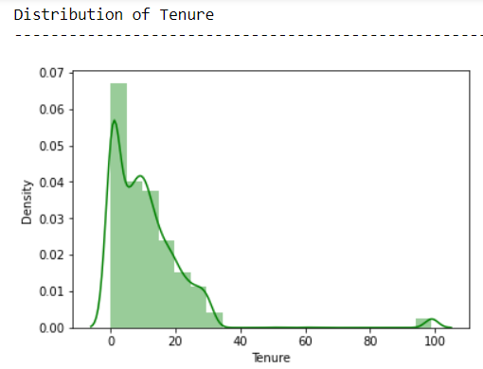
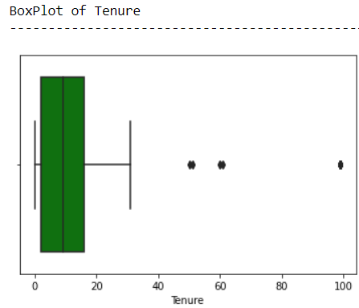
Tenure:
Figure 15 - Univariate Analysis of Tenure

Mean tenure is 11 with a standard deviation of 12.8. Skewness is 3.93 which means the distribution is right skewed which we can see from the distribution graph. The boxplot shows outliers on the right side.

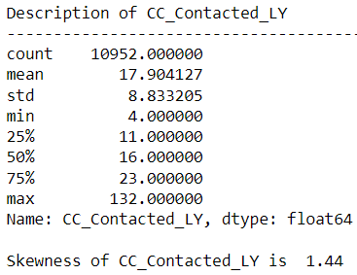
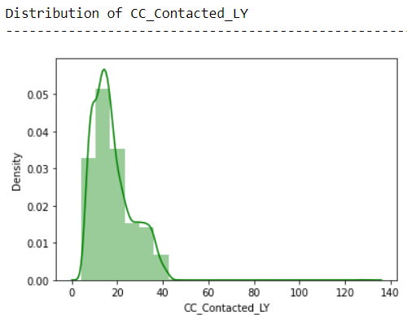
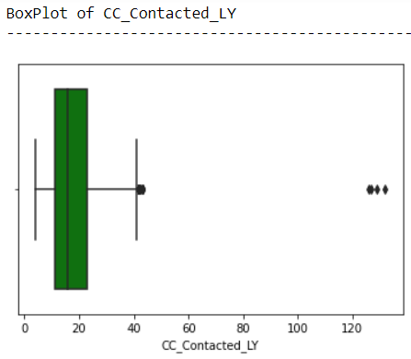
CC Contacted LY
Figure 16 - Univariate Analysis of CC contacted LY
Mean customer care contacts were 17.9 with a standard deviation of 8. Skewness is 1.44 which means the distribution is right skewed which we can see from the distribution graph. The boxplot shows outliers on the right side.

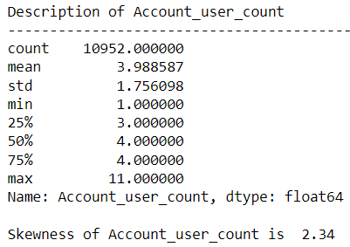
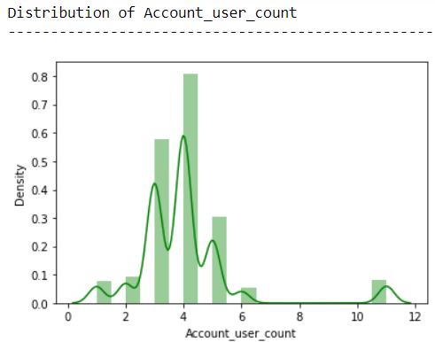
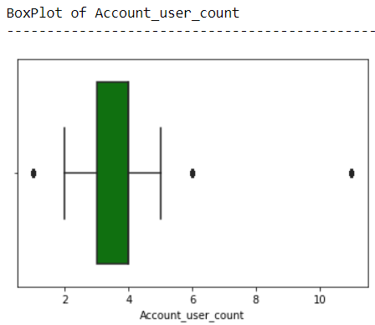
Account User Count
Figure 17 - Univariate Analysis of Account user count
Mean number of customers with each account are 4 approximately with a standard deviation of 2 approximately. Skewness is 2.34 which means the distribution is right skewed which we can see from the distribution graph. The boxplot shows outliers on the both sides.
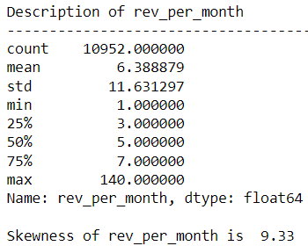
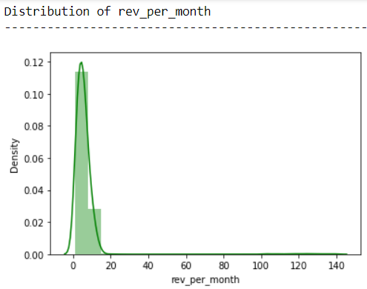
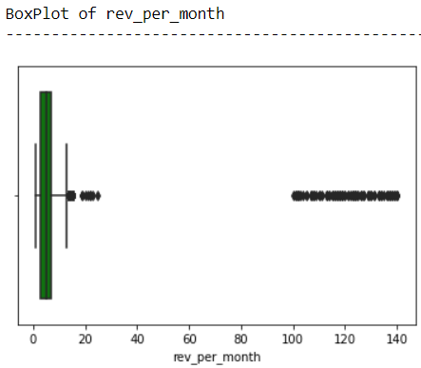
Revenue per Month
Figure 18 - Univariate Analysis of Revenue per month

Mean average revenue per month is 6 approximately with a standard deviation of 11 approximately. Skewness is 9.33 which means the distribution is highly right skewed which we can see from the distribution graph. The boxplot shows outliers on the right sides in huge amount.

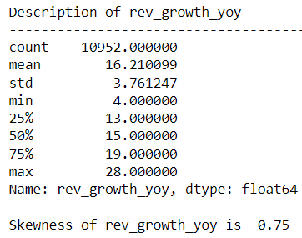
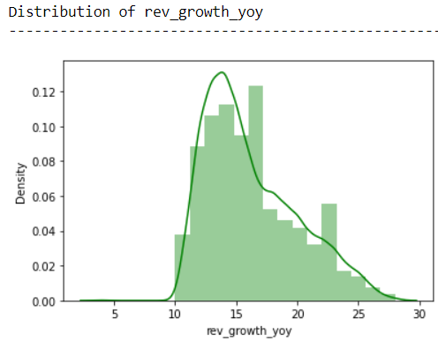
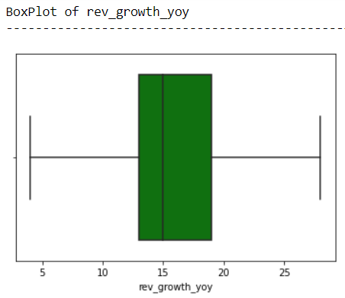
Revenue growth YOY
Figure 19 - Univariate Analysis of Revenue growth yoy
Mean revenue growth YoY is 6 approximately with a standard deviation of 3 approximately. Skewness is 0.75 which means the distribution is slightly right skewed which we can see from the distribution graph. The boxplot shows no outliers.

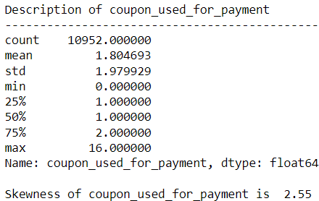
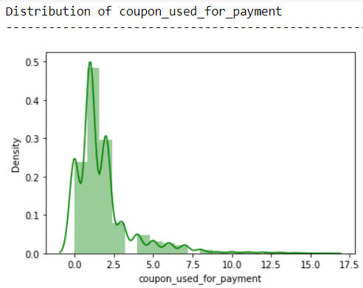
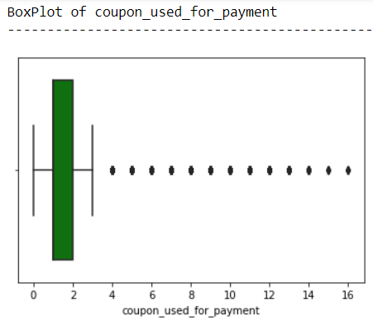
Coupon Used for Payment
Figure 20 - Univariate Analysis of Coupons used for payment
Mean number of coupons used for payment is 1.8 approximately with a standard deviation of 1.97 approximately. Skewness is 2.55 which means the distribution is right skewed which we can see from the distribution graph. The boxplot shows outliers on the right of the plot.

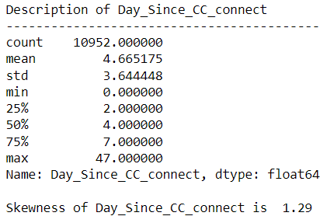
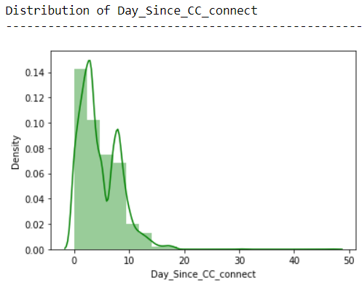
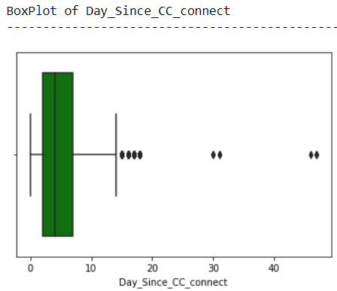
Days since customer care connect
Figure 21 - Univariate Analysis of Days since CC connect
Mean number of days since last cc connect is 4 approximately with a standard deviation of 3.6 approximately. Skewness is 1.29 which means the distribution is right skewed which we can see from the distribution graph. The boxplot shows outliers on the right of the plot.

Cashback
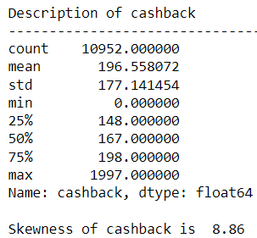
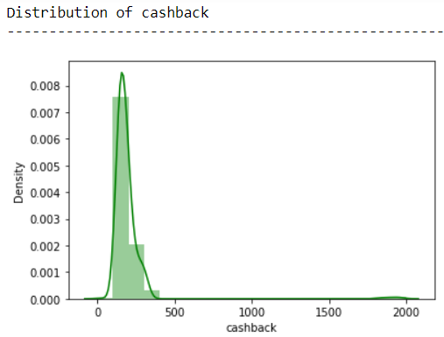
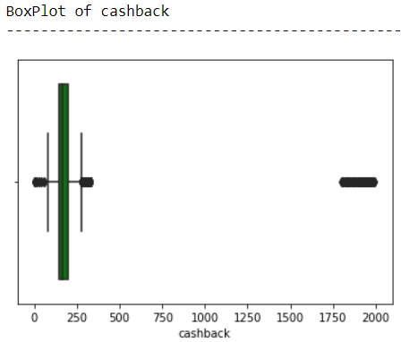
Mean cashback amount is 196 approximately with a standard deviation of 177 approximately. Skewness is 8.86 which means the distribution is highly right skewed which we can see from the distribution graph. The boxplot shows outliers on the extreme right of the plot as well as some to the lower end.
Figure 22 - Univariate Analysis of Cashback
Now we move on to look at the univariate analysis of categorical variables. We will be looking into the frequency distribution using Histogram.
Churn
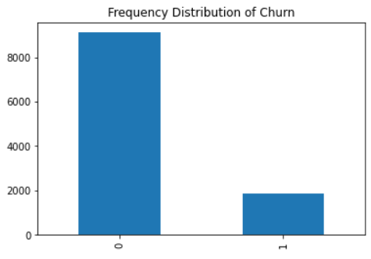
From the adjacent plot we can see that the accounts which churned are way less than the accounts which did not churn. Approximately 9000 accounts didn’t churn whereas approximately 2000 did. Churn is also our target variable in this project.

Figure 23 - Frequency Distribution of Churn

City Tier
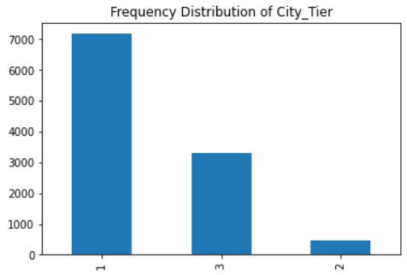
Most of the accounts (Approximately 7000) are from Tier 1 cities. Tier 2 has the least number of accounts (Approximately 500) whereas Tier 3 cities have approximately 3000 accounts.
Figure 24 - Frequency Distribution of City tier

Payment
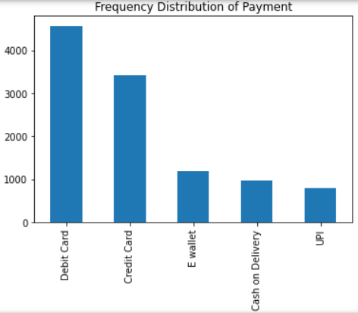
Most of the payments are made using Debit card. UPI is the least used payment mode followed by cash on delivery. Credit card is the 2nd highest used mode of payment.
Figure 25 - Frequency Distribution of Payment mode

Gender
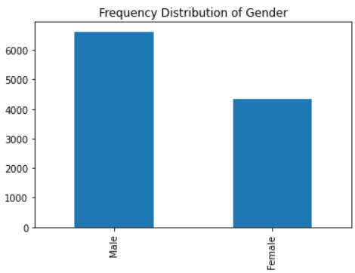
Most of the primary account holders are male. There are approximately 6500 male primary account holders whereas approximately 4000 female primary account holders.
Figure 26 - Frequency Distribution of Gender

Service Score
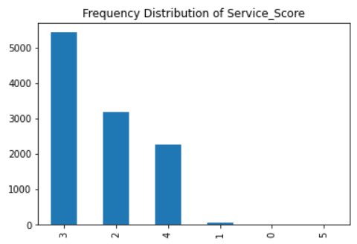
Most of the customers have given a service satisfaction score of 3 to the company followed by a score of 2 and 4. That means most of the customers give an average service satisfaction score. Only a handful of customers have given scores of 0, 1 and 5.
Figure 27 - Frequency Distribution of Service Score

Account Segment
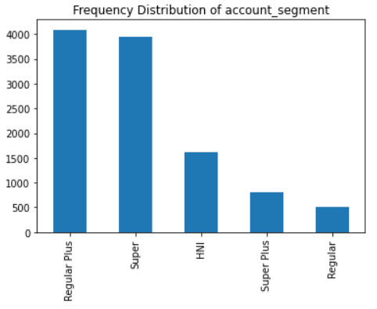
Most of the accounts are segmented as Regular plus and Super. Approximately 7800 accounts are segmented into Regular plus and Super. The company also has nearly 1500 HNI accounts. Super plus and Regular segmentations have least number of accounts.

Figure 28 - Frequency Distribution of Account segment

Customer care agent score
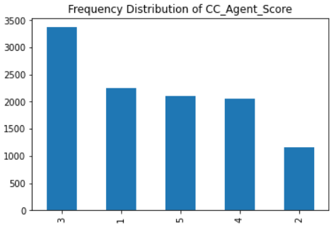
Most of customers have given the customer care agents a score of 3. A score of 1, 5 and 4 was given by approximately 2000 customers each. Score of 2 was given by least number of customers, nearly 1200.

Figure 29 - Frequency Distribution of CC agent score

Marital Status
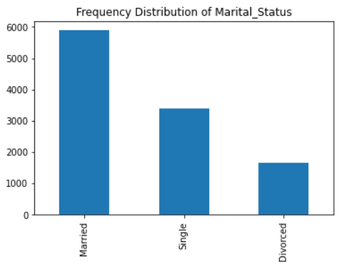
Approximately 6000 primary account holders are married whereas nearly 3000 of them are single and almost 1500 are divorced.
Figure 30 - Frequency Distribution of Marital status

Login Device
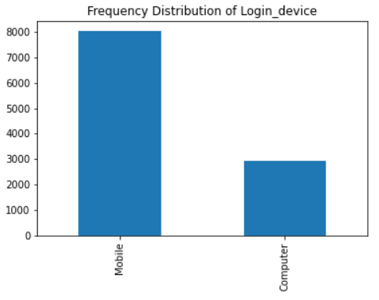
Approximately 8000 customers login with a Mobile and only 3000 approximately login using a computer.

Figure 31 - Frequency Distribution of Login device

g. Bivariate analysis (relationship between different variables, correlations)
We will look into the relationships of variables with each other and try to find out the dependency or correlations between the variables.
Our target variable churn will help us in knowing how a variable is changing with respect to the target.
Starting with tenure.
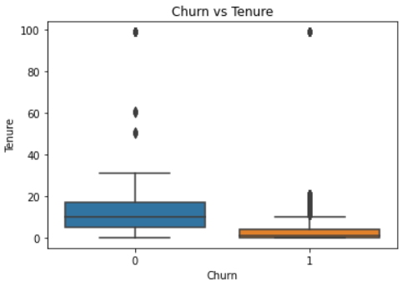
From the adjacent plot, we can infer that the accounts which do not churn have higher Tenure than the ones which churned. So, aim for accounts to have a longer tenure.

Figure 32 - Churn vs Tenure

We can also check for the average revenue per month vs churn
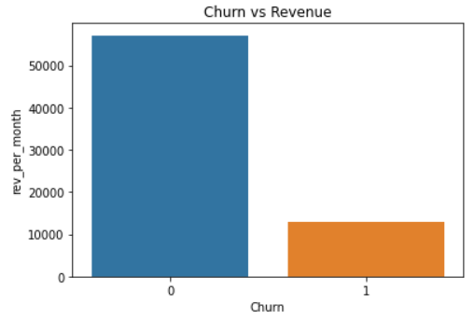
The sum of average revenues of churned accounts is lower than the sum of average revenues of non-churned accounts.
Figure 33 - Churn vs Revenue

City tier is also an area where we can check the traction of accounts.
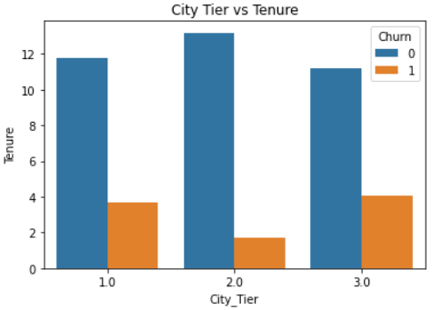
For the accounts that did not churn, the highest average tenure was in tier 2 cities while lowest was in tier 3 cities.
For the accounts which churned, tier 3 cities had highest tenure while tier 2 cities have lowest churn.

Figure 34 - City Tier vs Tenure
Plotting a scatter plot between tenure and average revenue per month to check if there is any correlation between them.
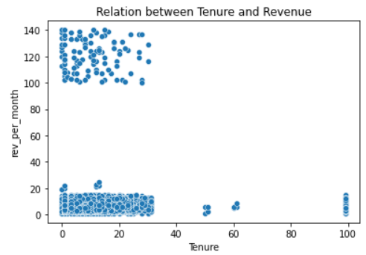
Looking at the adjacent graph, it seems there is no correlation between tenure and average revenue per month. Though we can see outliers in this graph which we will have to deal with.

Figure 35 - Tenure vs Revenue

Let us now look into the payment modes. How are the accounts distributed and how many of them churned?
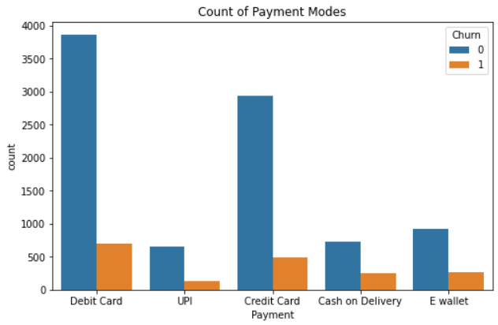
Figure 36 - Payment mode vs churn
The highest number of accounts churned were the ones whose payment mode was Debit card or credit card.
Customers churned across all payment modes without exception.

If we check the gender of the primary account holder versus churn.
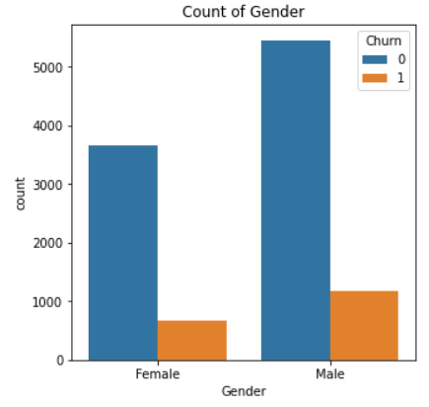
We find that male account holders are more in number and the churners are more as well in comparison to females.

Figure 37 - Gender vs churn
Let us also check the number of customers tagged to accounts and bifurcate with respect to churn.
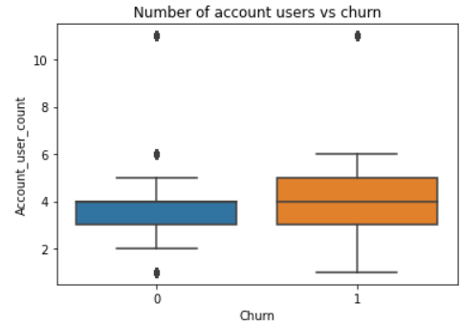
From the adjacent plot we can say that the accounts that churned have a greater number of customers tagged to them in comparison to the accounts that did not churn.

Figure 38 - Accounts users vs churn

Moving on to the account segments and checking how it varies with respect to churn.
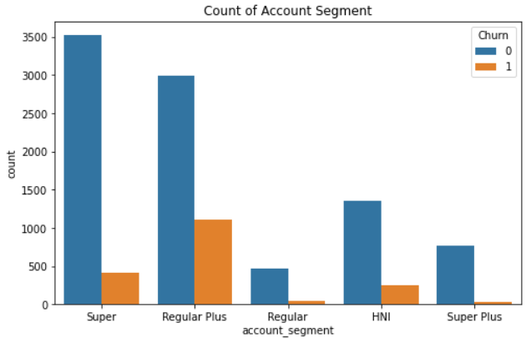
Regular plus accounts have the highest number of churners whereas super plus and regular customers have lower churning rate.

Figure 39 - Account segment vs churn

The satisfaction of service scores given by customers vs churn can also be checked.
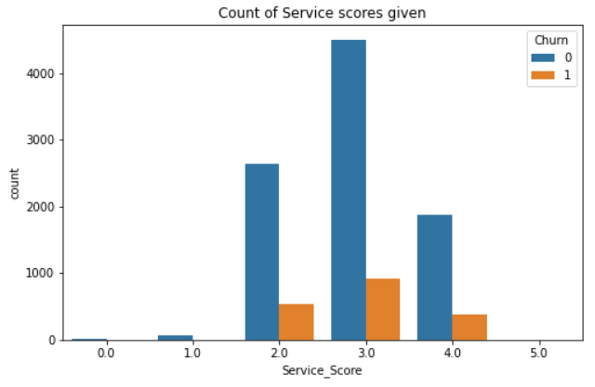
Most of the customers gave a score of 3. It comprised of both non-churners and churners. Scores do not help much in identifying the difference in habit of churners.

Figure 40 - Service score vs churn
Days since last customer care connect should be lower for churners as dissatisfied customer would connect with customer care more frequently.
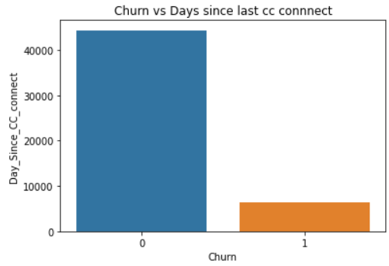
As hypothesized, the customers who churned have far lesser number of days since last customer care connect than the customers who did not churn.

Figure 41 - Days since cc connect vs churn

h. Multivariate Analysis (Heatmap)
A heatmap is the best way to perform a multivariate analysis. A heatmap gives the correlation score between all numerical variables in the dataset. It makes pair of 2 variables (all combinations taken into consideration) and gives correlation score between all pairs.
A correlation score tending to 1 means high positive correlation, a correlation score tending to -1 means high negative correlation, a correlation scores near to 0 means no correlation.
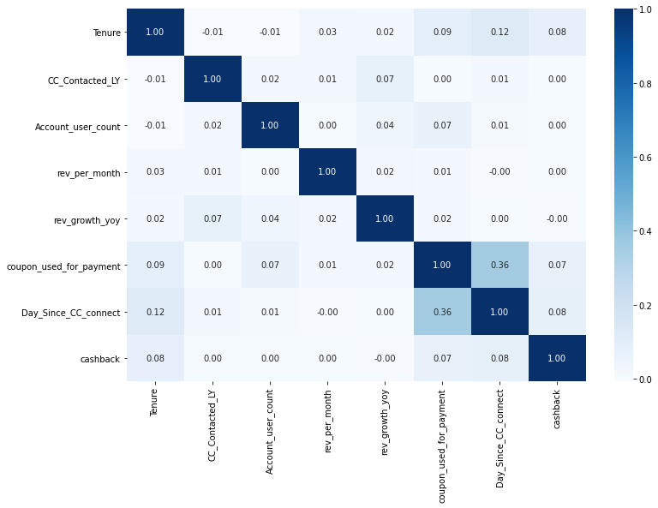
Figure 42 - Heatmap of numerical variables
From the above heatmap we can see that there is no major correlation between any two variables in the dataset. We are not facing the curse of multicollinearity in this dataset.
The maximum positive correlation can be seen between the variable’s coupon used for payment and days since last customer care connect. Rest, no multicollinearity in the dataset observed.

i. Outlier Treatment
We have already seen that our dataset has a lot of variables which have outliers present in them. Let us look at boxplot of all numerical variables again.

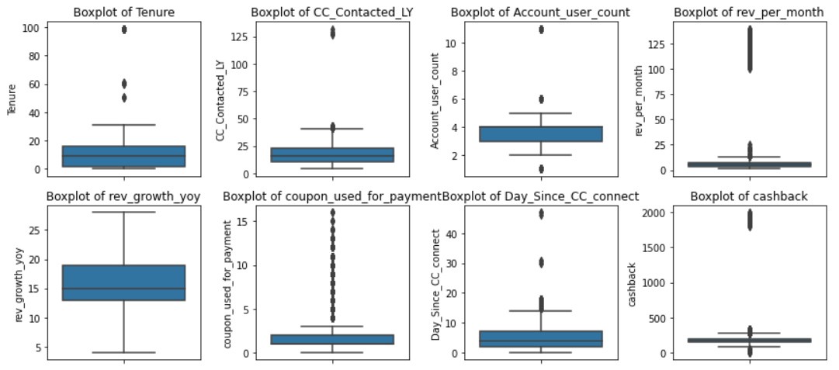
Figure 43 – Boxplots before outlier treatment
All variables have the presence of outliers except for one. The outliers would be a problem in model building exercise to be performed later. So, we will be treating these outliers using proper measures.
To treat the outliers, we replace the values which are greater than the upper range of the variable to the upper range and the values which are lower than the lower range of the variable.
Upper range = 3rd quartile + (1.5 * IQR)
Lower range = 1st quartile – (1.5 * IQR)
Let us now check the boxplots of all variables again once the outliers are treated.
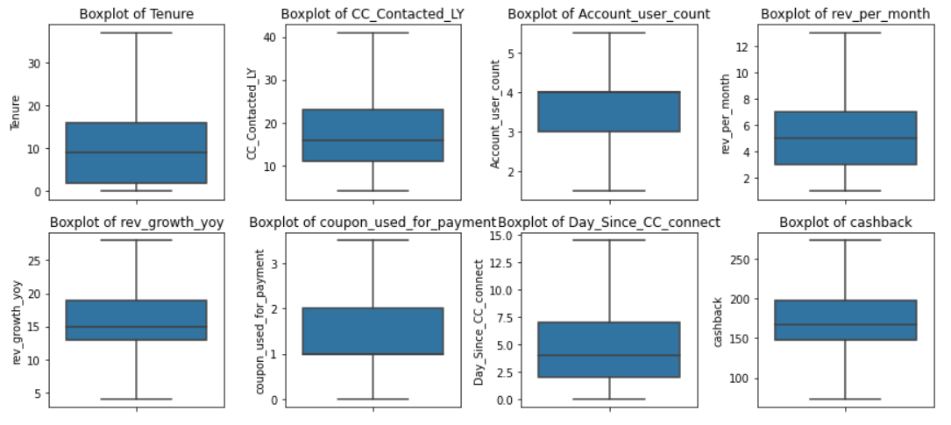
Figure 44 - Boxplots after outlier treatment
All outliers have been successfully treated.

4. Business insights from EDA

a. Is the data unbalanced? If so, what can be done? Please explain in the context of the business.
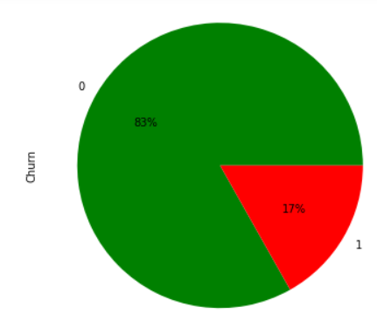
On exploring our dataset, we find out that there are 9108 accounts which have not churned and 1844 accounts have churned.
Figure 45 - Data Balance check
From the adjacent plot we can see that 0’s (Not churned accounts) cover about 83% data whereas 1’s (churned accounts) cover only 17%.

Thus, we can see that the data is imbalanced. But a 83:17 ratio might work in our churn dataset. There are various ways to deal with this imbalance in dataset. Let us look at all possibilities one by one:

- Checking the performance metrics after model building:
The first way is to keep the data like this and build a model and check for performance metrics. If they are giving good results then there will be no need of working on data imbalance.
The important sales metrics is precision in our case. Precision tells us how many of the accounts did we correctly label as churned accounts.
- Undersampling
Undersampling consists of deleting observations from your over-represented class. In this case, those would be the active customers. This makes sense to do when you have a whole lot of data. But it is not true in our case. So, we will not apply this.
- Oversampling
Oversampling consists of adding copies of observations from your under-represented class. In this case, those would be the churned customers.
- SMOTE
SMOTE stands for Synthetic Minority Over-sampling Technique. This method creates synthetic samples of your data, so rather than taking copies of observations, SMOTE uses a distance measure to create synthetic samples of data points that would not be far from your data points.
We can use these techniques to overcome the imbalance in our dataset. We will be choosing later which one to use for our model building exercise. If needed, SMOTE would be our best option to go with in this project.

b. Any business insights using clustering
Cluster analysis or clustering is the task of grouping a set of objects in such a way that objects in the same group (called a cluster) are more similar (in some sense) to each other than to those in other groups (clusters).
Before performing cluster analysis on our dataset, we will have to scale our data. Clustering exercise is based on distance calculation. If the data is not scaled, the result from clustering analysis will not be accurate. Thus, it is important to scale the data before doing clustering.
We will be scaling our dataset using the standard scalar function from sklearn library. StandardScaler is used to resize the distribution of values ​​so that the mean of the observed values ​​is 0 and the standard deviation is 1.
Now we move on to clustering analysis. We will be performing Hierarchical clustering on our dataset using wardlink method.
Once the wardlink linkage method is done, we create a dendrogram with the last 25 cut made on the dendrogram. The final dendrogram looks as below:
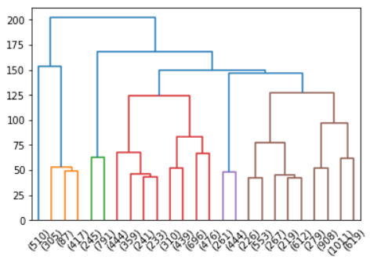
Figure 46 - Dendrogram (Hierarchical Clustering)
We can see that there are 5 prominent clusters that can be made in our data. We use the fcluster function with wardlink linkage and 5 cluster option to finally segregate our dataset based on clusters.

The 5 clusters made in the dataset are divided as follows:
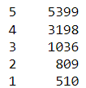
The adjacent image gives the number of records in each cluster.

Figure 47 - Clusters shape
The analysis from this clustering exercise can be checked by aggregating the means of variables based on the clusters formed.
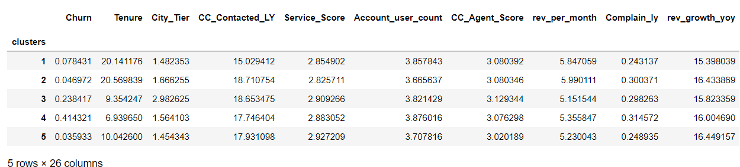
Table 4 - Cluster Aggregation
We check the Tenure of accounts across different clusters.
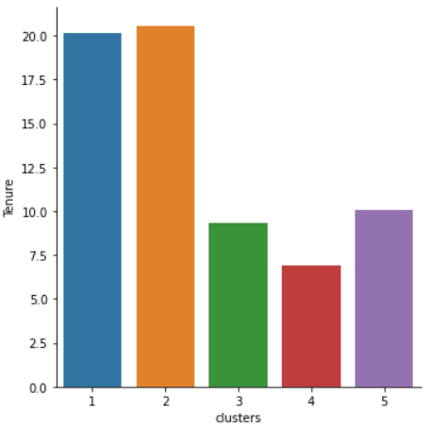
Cluster 1 and 2 are the ones which have accounts having high tenure.
Figure 48 - Cluster Analysis
Whereas, clusters 3 and 5 are the ones which have accounts having medium tenure.
While, cluster 4 has the accounts which have lowest tenure.

c. Any other business insights
The following insights can be drawn from the dataset after Exploratory Data Analysis:
- Tier 2 cities have the lowest number of accounts while tier 1 cities have the most.
- UPI and E-wallet payments are very low as compared to payments made by debit and credit cards.
- Female primary account holders are lesser in number than Male primary account holder.
- A service satisfaction score of 3 is given by most of the customers. Score of 4 is less and 5 is only given by handful of customers.
- Most customers are Regular plus and Super segmented. The company has less customers for HNI, Super plus and Regular.
- Customer care service scores given by customers vary from 1 to 5. A score of 1, 2 and 3 was given by more than 6000 customers.
- The tenure of accounts which churned is lower than the tenure of accounts which did not.
- The accounts which churned have a greater number of customers tagged under them as compared to the accounts which have not churned.
- The customers who churned have a lower sum of days of last connect with customer care as compared to customers who did not churn. That means dissatisfied people have contacted customer care more frequently than the ones who did not churn.

